GROUP NUMBER: 2

Instructions

Introduction
This study aims to find out medical students’ perspectives on decision-making AI tools.
In this document, you will find 8 case studies of predictions made by two AI models. XAI (Explainable AI) methods are algorithms that allow users of an AI model to understand the decision-making processes behind its predictions.
You will be shown 8 predictions made by AI models that predict whether a patient will develop cancer based on a given set of patient factors. 4 cases are on colon cancer and 4 cases are on lung cancer.
Our team utilized XAI methods to provide explanations for how each AI model makes a prediction. The explanations are displayed with a bar chart.
Information has also been provided on factors which you may find unfamiliar.

How to interpret the predictions:
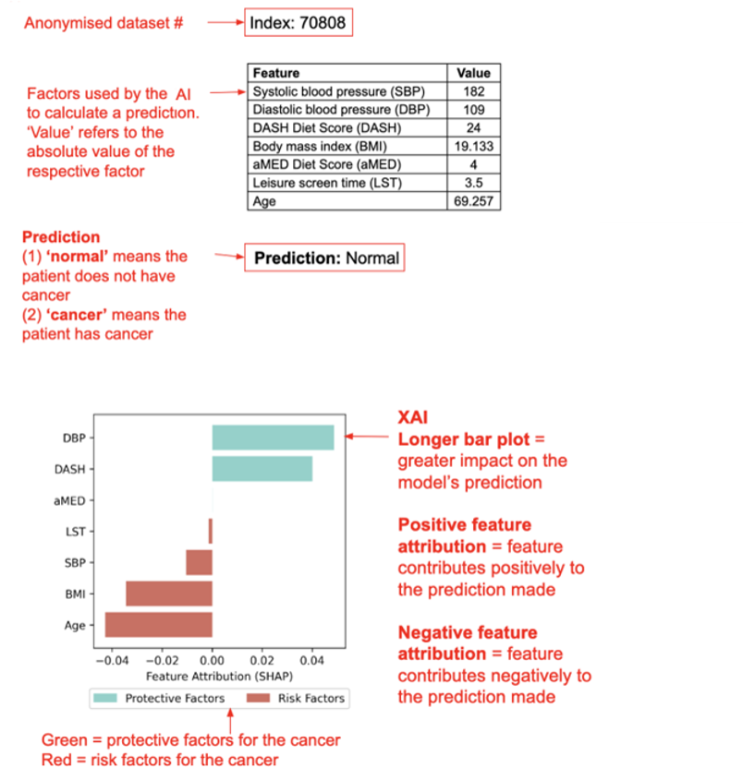

Colon cancer predictions

More information:
- Leisure screen time is recorded in hours per day
- DASH diet (Dietary Approaches to Stop Hypertension)
This DASH diet plan consists of 8 nutritional targets namely higher intakes of (1) whole grains, (2) fruits, (3) vegetables, (4) legumes and nuts, and (5) low-fat dairy, and lower intakes of (6) red or processed meats, (7) sodium, and (8) sweetened beverages.
The DASH diet score is based on the patient’s patient’s consumption of each of the 8 nutritional targets, which are scored from 1-5. Hence, scores range from 8-40 with 8 indicating minimal adherence to the DASH diet and 40 indicating maximal adherence.
- aMED diet (Alternate Mediterranean Diet Score)
The aMED diet plan focuses on higher consumption of plant foods including plant proteins, monounsaturated fat, fish, and lower consumption of animal products and saturated fat.
Studies have shown that the aMED diet is associated with reduced all-cause and cause-specific mortality.
Each of the 9 components are scored as 0 or 1, depending on whether the quantity consumed is more or less than the median intake of the study population. Hence, the total score ranges from 0 to 9, with a higher score being associated with lower risk of all-cause, CVD and cancer mortality.
Predictions:
The model was trained on data from 16,551 patients – 16,125 normal patients and 426 colorectal cancer patients. The model achieved an accuracy of 83.1% on the evaluation set.
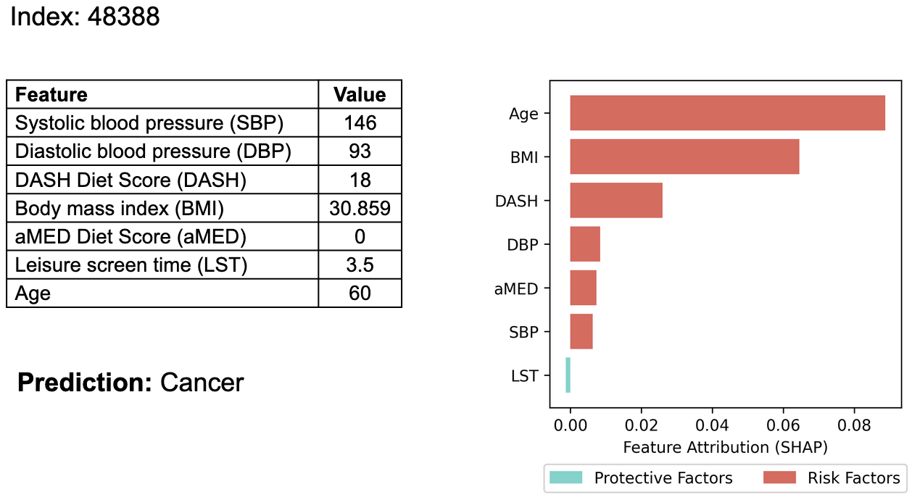
The model’s prediction was correct.
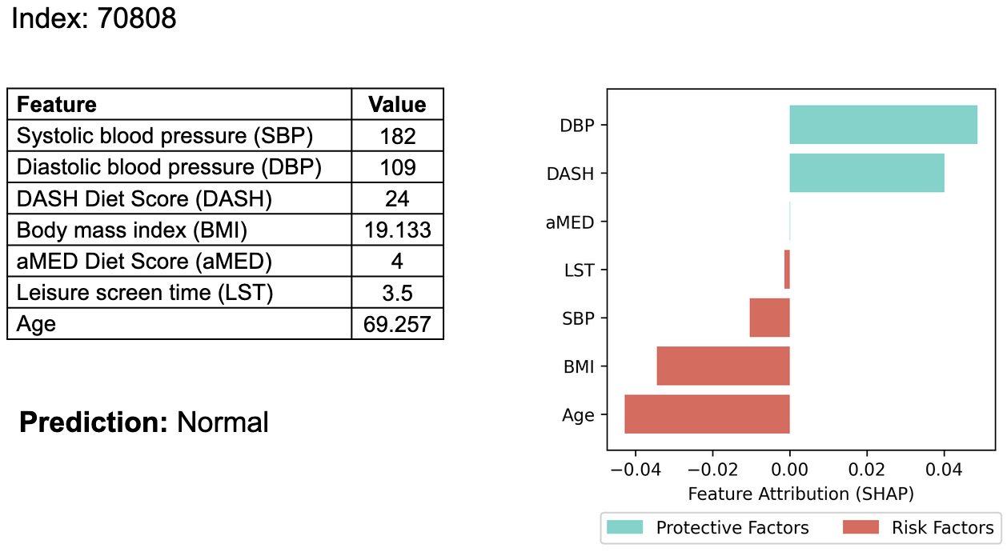
The model’s prediction was incorrect.
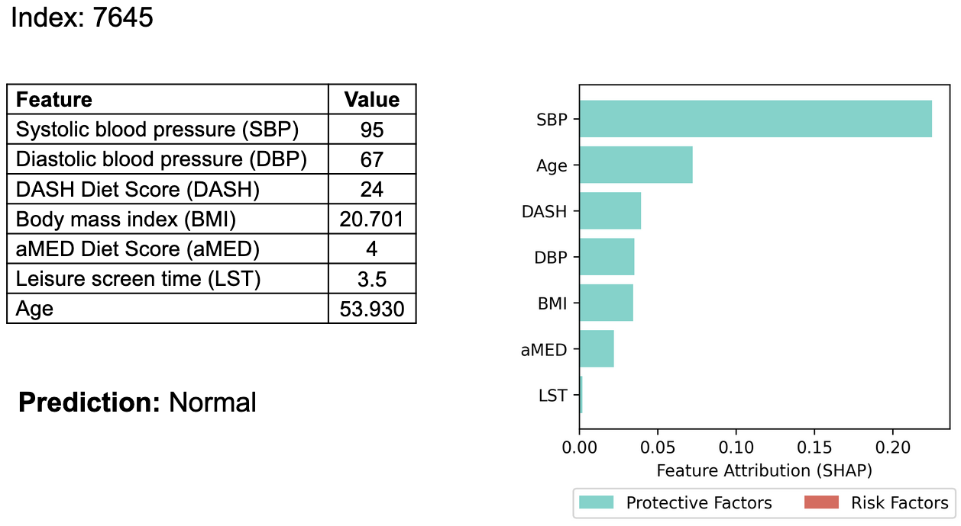
The model’s prediction was correct.
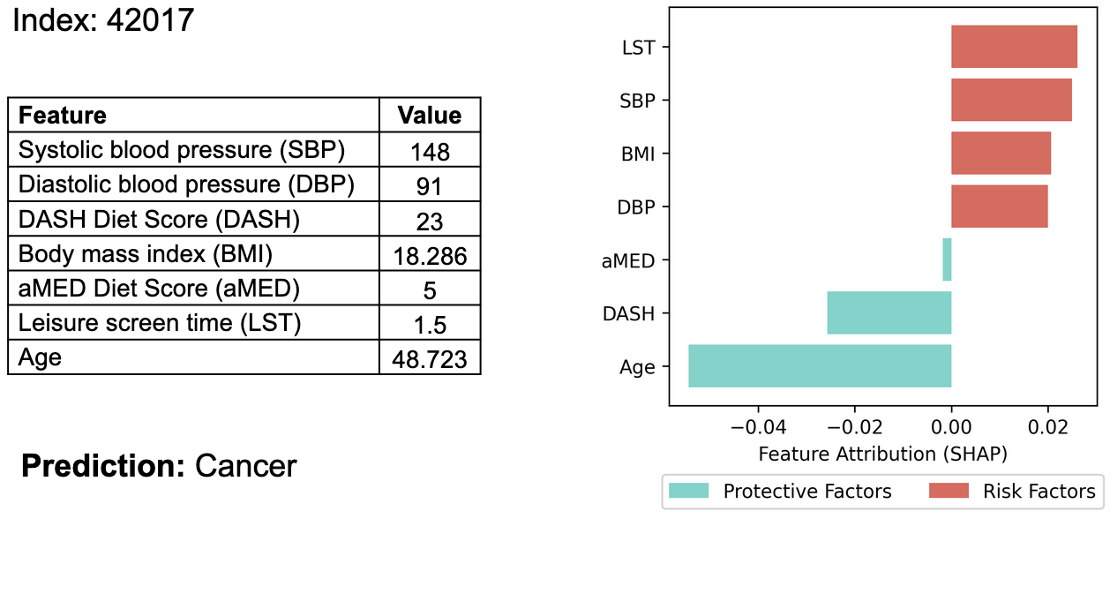
The model’s prediction was incorrect.

Lung cancer predictions

More information:
- PGS000721 & PGS000070
Polygenic risk scores measure a person’s risk of developing a certain disease based on genetic factors. PGS000721 is mapped to lung carcinoma and PGS000070 is mapped to lung adenocarcinoma.
- aHEI-2010 diet score (Alternative Healthy Eating Index)
The aHEI is a food rating system modified by Harvard researchers. It focuses on preventing chronic illness through adherence to the federal dietary guidelines for Americans.
The scoring system grades one’s diet based on their consumption of healthy and unhealthy foods. The total score ranges from 0 (nonadherence) to 110 (perfect adherence).
- Telomere length
A telomere is the region of repetitive sequences at the end of a chromosome. It becomes shorter each time a cell divides which occurs naturally with time.
When a telomere becomes too short, the cell can no longer divide and undergoes apoptosis (death).
There is no definite link between telomere length and cancer. However, some research shows that excessive shortening or lengthening of a telomere may be associated with various cancers.
Predictions:
The model was trained on data from 13,971 patients – 13,712 normal patients and 259 lung cancer patients. The model achieved an accuracy of 80.2% on the evaluation set.
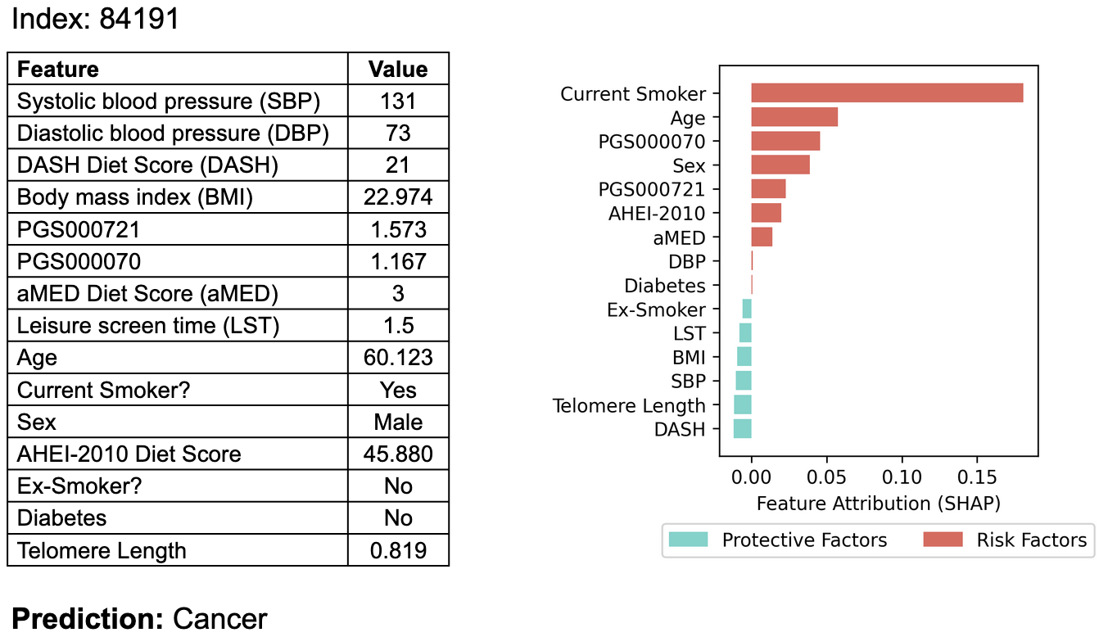
The model’s prediction was correct.
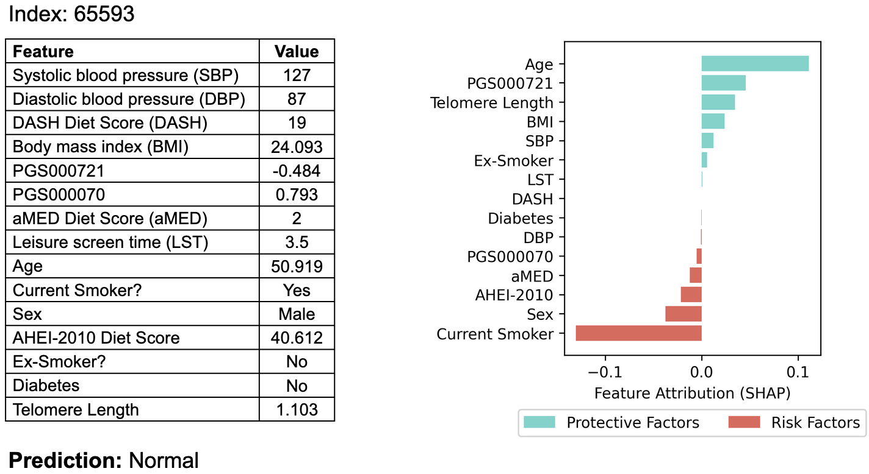
The model’s prediction was incorrect.
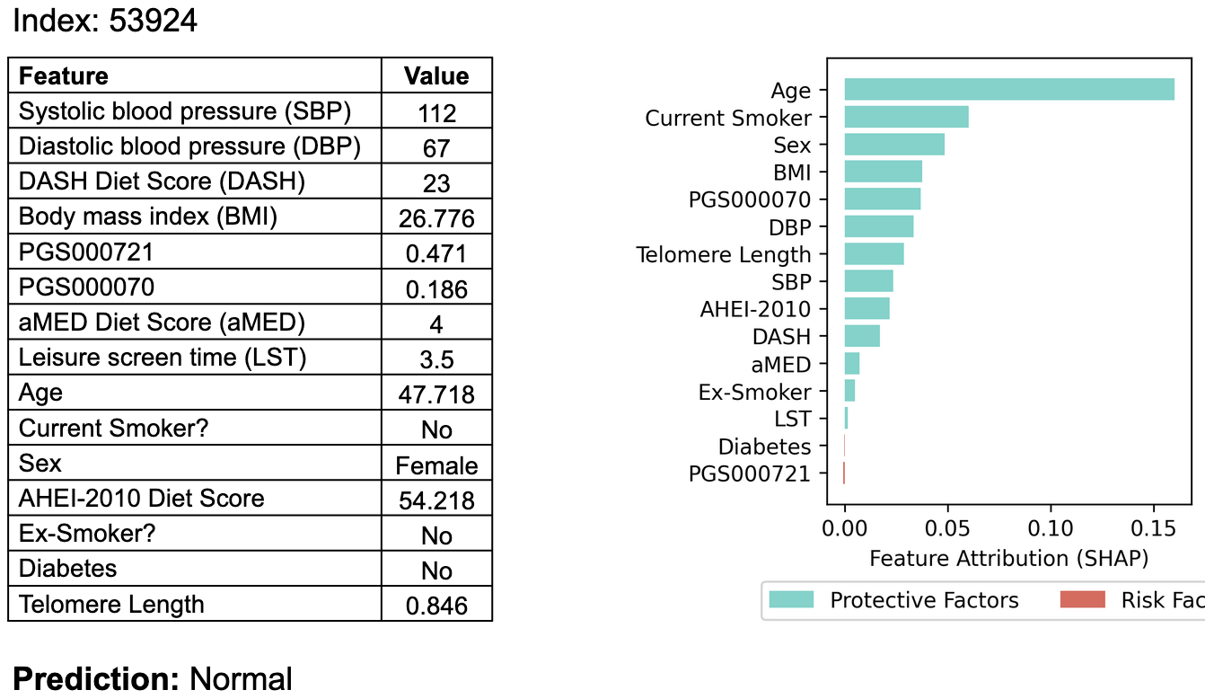
The model’s prediction was correct.
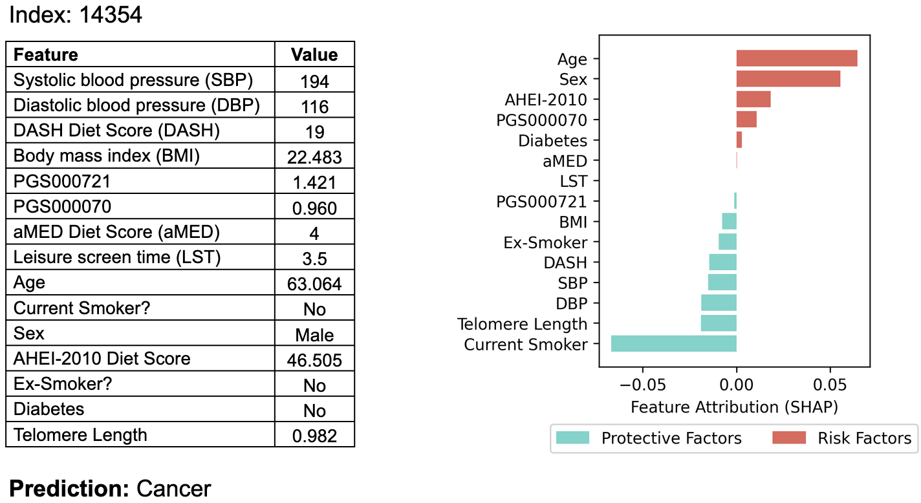
The model’s prediction was incorrect.

––––––––––––––––– You have reached the end of the document. ––––––––––––––––––

